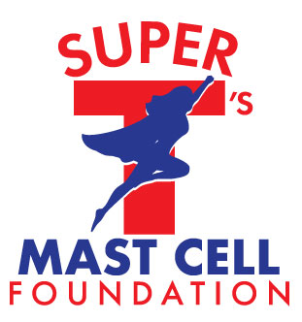 | 2020 Grant Application for  The TAYLOR NEARON GRANT

Introduction and Parameters
Super T’s Mast Cell Foundation (STMCF) was started based off a dream and passion fueled by “Super T”, Taylor Nearon. After receiving a medical diagnosis of a rare condition, otherwise known as Mast Cell Activation Disease, Taylor wanted to make a change. She took her passion for helping others to form this foundation ensuring patients always felt supported.
The creation of the Taylor Nearon Grant will be awarded to a recipient who reflects the same values, creativity and commitment to the MCAD community that was exhibited by Taylor during her valiant fight. Helping others no matter her circumstance was the cornerstone of who Taylor was.
For the 2020 grant selection, applications for the Taylor Nearon Grant will be accepted from March 1, 2020 – September 30, 2020, with all recipients being notified by October 31, 2020. Super T’s Mast Cell Foundation will not be responsible for lost or misdirected e-mail, mail, or applications post marked after September 30, 2020.
STMCF and its Board of Directors and Officers certify and promise that all information/documentation obtained from applicants/patients and letters from physicians will be kept confidential and stored in a secure and safe location and solely viewed by the Board of Directors and Officers of Super T's Mast Cell Foundation for the purposes of determining grant eligibility and distribution; the information and documentation provided will not be used for any other purpose.

Before you begin, please review the grant criteria outlined below. Place an “X” in each box to ensure eligibility.

I have been diagnosed with a mast cell activation disease less than 5 years. |  |  |  | YES | NO
I am the patient and am 18 years of age or older. |  |  |  | YES | NO

I am a family member or guardian applying on behalf of a patient with his/her approval. (Please provide documentation supporting this.)

I have an official diagnosis of a Mast Cell activation Disease, this includes Mastocytosis or Mast Cell Activation Syndrome. (Please provide a letter from your treating physician documenting diagnosis.)

I have not been awarded a grant in the past two years.

If selected to become a grant recipient, I will write a brief testimony reflecting the impact of being awarded a grant.

Grant Applicant Information
Full Name: |  |  |  | Date:
 | Last | First | M.I.

Address:
 | Street Address | Apartment/Unit #

 | City | State | ZIP Code

Phone: |  | Email

Please answer the following questions:
- What is your hobby? Example, crafting, blogging, journaling, Facebook group, etc.?
- How have you made an impact on the MCAD community?

- How do you balance having a chronic illness with everyday expectations?

- What is your motivation each day?

- Are you part of any groups? Example online mcad community

